**A**

***PROJECT REPORT***

*on*

**Thought Sync**

*Submitted in partial fulfilment of the requirements for the degree of*

**BACHELOR OF TECHNOLOGY**



Session: - 2024





**A**

***PROJECT REPORT***

*on*

**Thought Sync**

*Submitted in partial fulfilment of the requirements for the degree of*

**BACHELOR OF TECHNOLOGY**



**Session: - 2024**







Department of Computer Science and Engineering

Techno India NJR Institute of Technology, Udaipur-313001

**Certificate**

This is to certify that project work titled “**Thought Sync”** by **Deepansha Baya** was successfully carried out in the Department of Computer Science and Engineering, TINJRIT and the report is approved for submission in the partial fulfillment of the requirements for award of degree of Bachelor of Technology in Computer Science and Engineering.

Aaditya Maheshwari Dr. Rimpy Bishnoi

Assistant Professor Professor and HOD

Computer Science & engineering Dept. of CSE TINJRIT, Udaipur

Date...................... Date......................



Department of Computer Science and Engineering

Techno India NJR Institute of Technology, Udaipur-313001

**Certificate**

This is to certify that project work titled “**Thought Sync”** by **Yashasvi Jhala** was successfully carried out in the Department of Computer Science and Engineering, TINJRIT and the report is approved for submission in the partial fulfillment of the requirements for award of degree of Bachelor of Technology in Computer Science and Engineering.

Aaditya Maheshwari Dr. Rimpy Bishnoi

Assistant Professor Professor and HOD

Computer Science & engineering Dept. of CSE TINJRIT, Udaipur

Date...................... Date......................



Department of Computer Science and Engineering

Techno India NJR Institute of Technology, Udaipur-313001

**Examiner Certificate**

This is to certify that the following student **Deepansha Baya** of final year B.Tech. (Computer Science and Engineering), was examined for the project work titled

***“Thought Sync ”***

during the academic year 2023 – 2024 at Techno India NJR Institute of Technology, Udaipur

**Remarks:**

**Date:**

Signature Signature

(**Internal Examiner**) (**External Examiner**)

Name :- ……………………… Name :- ………………………

Designation:- ……………….. Designation:- ………………..

Department: - ………………. Department: - ……………….

Organization:- ……………… Organisation:- ………………



Department of Computer Science and Engineering

Techno India NJR Institute of Technology, Udaipur-313001

**Examiner Certificate**

This is to certify that the following student **Yashasvi Jhala** of final year B.Tech. (Computer Science and Engineering), was examined for the project work titled

***“Thought Sync”***

during the academic year 2023 – 2024 at Techno India NJR Institute of Technology, Udaipur

**Remarks:**

**Date:**

Signature Signature

(**Internal Examiner**) (**External Examiner**)

Name :- ……………………… Name :- ………………………

Designation:- ……………….. Designation:- ………………..

Department: - ………………. Department: - ……………….

Organization:- ……………… Organisation0:- ………………

**Preface**

This document serves as a comprehensive overview of the project, detailing its objectives, methodologies, challenges faced, and future enhancements.

Creating a Reddit clone presented an exciting opportunity to explore modern web development technologies and build a platform that replicates the core features of one of the internet's most popular discussion forums. With the proliferation of social media platforms, there is a growing demand for customizable, scalable, and user-friendly community-driven platforms. Our aim was to meet this demand by leveraging cutting-edge technologies and best practices in web development.

Throughout the project, we adhered to a structured development approach, beginning with the initial setup and configuration of the development environment. We meticulously designed and implemented the frontend user interface using React.js and Ant Design, ensuring an intuitive and visually appealing user experience. On the backend, we employed Supabase for database management and real-time updates, coupled with TypeORM and TypeGraphQL for efficient database operations and GraphQL API development.

This project report provides a detailed account of our journey, from the literature review of relevant technologies to the methodology adopted for development. We discuss the challenges encountered during the development process and outline potential future enhancements to further improve the platform's functionality and usability.

We hope this project report serves as both a testament to our hard work and a valuable resource for fellow developers seeking insights into building modern web applications. We invite you to explore the report and delve into the intricacies of our Reddit clone project.

DEPARTMENT OF COMPUTER SCIENCE AND ENGINEERING TECHNO INDIA NJR INSTITUTE OF TECHNOLOGY, UDAIPUR-313001

**ACKNOWLEDGMENT**

We take this opportunity to record our sincere thanks to all who helped us to successfully complete this work. Firstly, we are grateful to our **supervisor Mr. Aaditya Maheshwari** for his invaluable guidance and constant encouragement, support and most importantly for giving us the opportunity to carry out this work.

We would like to express our deepest sense of gratitude and humble regards to our

**Head of Department Dr. Rimpy Bishnoi** for giving invariable encouragement in our endeavours and providing necessary facilities for the same. Also a sincere thanks to all faculty members of CSE, TINJRIT for their help in the project directly or indirectly.

Finally, We would like to thank my friends for their support and discussions that have proved very valuable for us. We are indebted to our parents for providing constant support, love and encouragement. We thank them for the sacrifices they made so that we could grow up in a learning environment. They have always stood by us in everything we have done, providing constant support, encouragement and love.

**Deepansha Baya (20ETCCS025)**

**Yashasvi Jhala (20ETCCS120)**

DEPARTMENT OF COMPUTER SCIENCE AND ENGINEERING

TECHNO INDIA NJR INSTITUTE OF TECHNOLOGY, UDAIPUR-313001

**List of Figures**

| **Fig No.** | **Title** | **Page no.** |
| --- | --- | --- |
| 6.1 | Authentication | 20 |
| 6.2 | Landing Page | 20 |
| 6.3 | Create a Post | 21 |
| 6.4 | Posts Page | 21 |
| 6.5 | Enabled Animations | 22 |

# **CONTENTS**

| Certificate | i |
| --- | --- |
| Examiner Certificate | ii-v |
| Preface | vi |
| Acknowledgement | vii |
| List of Figures | viii |
| List of Tables | x |
| **Chapter 1** INTRODUCTION | 12 |
| 1.1 Background | 12 |
| 1.2 Problem statement | 12 |
| 1.3 Objective and Scope | 12 |
| **Chapter 2** Literature and Review | 13 |
| 2.1 Introduction | 13 |
| 2.2 React.js and the Component-Architecture | 13 |
| 2.3 GraphQL: A New Approach to APIs | 13 |
| 2.4 Serverless and Backend as a Service (BaaS) | 13 |
| 2.5 TypeScript and Strongly Typed Languages | 13 |
| 2.6 Reddit Clone Project | 13 |
| **Chapter 3** Methodology | 14-15 |
| 3.1 Methodology | 14 |
| 3.1.1 Project setup and environment | 14 |
| 3.1.2 Architecture and Integration | 14 |
| 3.1.3 Visual Data Processing | 14 |
| 3.1.4. Code Execution Capability | 14 |
| 3.1.5. Iterative Development and Testing | 15 |
| 3.1.6. Documentation and Deployment | 15 |
| 3.1.7. User Training and Support | 15 |
| **Chapter 4** Development Process | 16-17 |
| 4.1 Initial Setup and Configuration | 16 |
| 4.2 Project Planning | 16 |
| 4.2.1 Team Formation | 16 |
| 4.2.2 Environment Setup | 16 |
| 4.3 Implementation | 16 |
| 4.3.1 Frontend Development | 16 |
| 4.3.2 User Interface Design | 16 |
| 4.3.3 Integration of External Services | 17 |
| **Chapter 5**  Results and Discussion | 18-19 |
| 5.1 Evaluation Metrics | 18 |
| 5.2 Performance Metrics | 18 |
| 5.3 Accuracy Rates | 18 |
| 5.4 User Satisfaction Scores | 18 |
| 5.5 User Feedback | 18 |
| 5.5.1 Qualitative Feedback | 19 |
| 5.5.2 Quantitative Feedback | 19 |
| 5.6 Challenges Encountered | 19 |
| 5.7 Technical Challenges | 19 |
| 5.8 Resource Constraints | 19 |
| **Chapter 6** Figures | 20-22 |
| **Chapter 7** Conclusion | 23 |
| Appendices | 24 |
| References | 24 |

**Chapter 1**

**INTRODUCTION**

**1. 1 Background:**

* The Reddit clone project aimed to replicate the functionality of the popular social news aggregation and discussion website, Reddit, using modern web development technologies.
* By leveraging React.js for the client-side interface, Ant Design for UI components, GraphQL Codegen for generating TypeScript types from GraphQL schemas, Supabase for the backend, and TypeORM with TypeGraphQL for server-side database operations, the project sought to create a scalable, maintainable, and feature-rich platform for users to engage in discussions, share content, and interact with each other.

**1.2 Problem Statement:**

The problem statement revolves around the creation of a Reddit clone, a web-based platform that enables users to share content, participate in discussions, and interact with each other within specialised communities or "subreddits". The platform should offer features such as user authentication, post creation, commenting, voting, and real-time updates while prioritising scalability, maintainability, and user experience.

**1.3 Objective and Scope :**

Objective :

* Functional Reddit-like Platform: Develop a fully functional platform with features such as user authentication, post creation, commenting, and voting, closely resembling Reddit's core functionality.
* Modern Technology Stack: Utilise modern technologies including React.js, Ant Design, GraphQL, Supabase, TypeORM, and TypeGraphQL to ensure the scalability, maintainability, and performance of the application.
* Scalability and Maintainability: Architect the application in a way that promotes scalability and maintainability, allowing for easy addition of new features and enhancements in the future.

Scope:

* Designing and implementing client-side interfaces for content browsing, posting, and interaction.
* Developing server-side components for user authentication, data storage, and real-time updates.
* Integrating third-party services or libraries for enhanced functionality and features.

**Chapter 2**

**Literature Review and Evolution of Web Development Technologies**

**2.1 Introduction :**

The evolution of web development technologies has been rapid, driven by the need for more efficient, scalable, and interactive web applications. This literature review explores the progression of key technologies and frameworks relevant to building modern web applications, leading up to the development of the Reddit clone project.

**2.2 React.js and the Component-Based Architecture :**

React.js, introduced by Facebook in 2013, revolutionised frontend development with its component-based architecture and virtual DOM rendering. React's declarative approach to building user interfaces simplified the development process and improved performance.

**2.3 GraphQL: A New Approach to APIs :**

GraphQL, developed by Facebook in 2015, addressed limitations of traditional REST APIs by allowing clients to request precisely the data they need. With GraphQL, developers can define a schema that specifies the available data and queries, providing flexibility and efficiency in data fetching.

**2.4 Serverless and Backend as a Service (BaaS) :**

The rise of serverless architecture and Backend as a Service (BaaS) platforms like Firebase and Supabase simplified backend development by abstracting away server management and infrastructure concerns. These platforms offer scalable, real-time databases and authentication services, enabling rapid application development.

**2.5 TypeScript and Strongly Typed Languages :**

TypeScript, introduced by Microsoft in 2012, brought static typing to JavaScript, enhancing code quality and developer productivity. TypeScript's type system provides compile-time type checking and enables better tooling support, leading to more robust and maintainable codebases.

**2.6 Reddit Clone Project: Integration of Modern Technologies :**

The Reddit clone project represents the culmination of these technological advancements, leveraging React.js for the frontend interface, GraphQL for efficient data fetching, Supabase for backend services, and TypeScript for type safety and enhanced developer experience.

**Chapter 3**

**METHODOLOGY**

**3.1 Methodology :**

In this chapter, the methodology adopted for the development of the Reddit clone project is outlined. The methodology encompasses various stages, including project setup, architecture, visual data processing, code execution capability, iterative development and testing, documentation, deployment, and user training and support.

**3.1.1 Project Setup and Environment :**

The project setup involved configuring the development environment for both the client-side and server-side components. This included setting up necessary tools such as Node.js, package managers like npm or yarn, and version control systems like Git. IDEs (Integrated Development Environments) or code editors suitable for JavaScript and TypeScript development were chosen based on the team's preferences. Additionally, the necessary libraries and frameworks, including React.js, Ant Design, GraphQL Codegen, Supabase, TypeORM, and TypeGraphQL, were installed and configured.

**3.1.2 Architecture and Integration :**

The architecture of the Reddit clone project was designed to ensure scalability, maintainability, and extensibility. The client-side architecture followed a component-based approach, with reusable components organized into a clear folder structure. The server-side architecture leveraged GraphQL for defining schemas and resolvers, TypeORM for database interaction, and Supabase for real-time updates and authentication. Integration between the client and server was achieved through GraphQL APIs, facilitating efficient data exchange and synchronization.

**3.1.3 Visual Data Processing :**

Visual data processing involved designing the user interface (UI) to mimic the look and feel of Reddit while ensuring responsiveness and accessibility. Ant Design components were utilised to maintain consistency and streamline UI development. Consideration was given to user interactions such as posting, commenting, voting, and navigation, with a focus on providing an intuitive and seamless user experience.

**3.1.4 Code Execution Capability :**

The code execution capability of the Reddit clone project was optimized for performance and reliability. Best practices such as code splitting, lazy loading, and caching were employed to minimise load times and improve responsiveness. Error handling mechanisms were implemented to gracefully handle exceptions and provide meaningful feedback to users. Additionally, unit tests, integration tests, and end-to-end tests were conducted to verify the correctness and robustness of the codebase.

**3.1.5 Iterative Development and Testing :**

* The development process followed an iterative approach, with regular feedback loops and continuous integration. Features were implemented incrementally, with each iteration focusing on a specific set of functionalities.
* Testing was conducted at each stage of development, encompassing unit tests for individual components, integration tests for API endpoints, and end-to-end tests for user workflows. Feedback from testing was used to refine and improve the application iteratively.

**3.1.6 Documentation and Deployment :**

* Comprehensive documentation was maintained throughout the development process to facilitate collaboration and knowledge sharing among team members. This included documentation for code, APIs, architecture, and deployment procedures.
* Automated deployment pipelines were set up to streamline the deployment process and ensure consistency across environments. Continuous integration tools were used to automate testing and deployment, with checks for code quality and security vulnerabilities.

**3.1.7 User Training and Support :**

* User training and support were considered essential aspects of the project, ensuring that end-users could effectively utilise the Reddit clone platform. User documentation and tutorials were provided to guide users through the registration process, posting content, commenting, and engaging with other users.
* Additionally, support channels such as email, chat, or forums were established to address user inquiries, feedback, and technical issues promptly.

**Chapter 4**

**DEVELOPMENT PROCESS**

**4.1 Initial Setup and Configuration :**

* The initial setup and configuration phase of the development process involved preparing the development environment and installing necessary tools and dependencies. This included setting up Node.js, package managers, version control systems, and code editors.
* Additionally, libraries and frameworks such as React.js, Ant Design, GraphQL Codegen, Supabase, TypeORM, and TypeGraphQL were installed and configured for both client-side and server-side development.

**4.2 Project Planning :**

Project planning encompassed various activities aimed at organising resources, defining objectives, and establishing timelines for the development process.

**4.2.1 Team Formation :**

The project team was formed based on the required skill sets and expertise. Roles and responsibilities were defined for each team member, including frontend developers, backend developers, UI/UX designers, testers, and project managers.

**4.2.2 Environment Setup :**

The development environment was set up to provide a conducive workspace for the project team. This included configuring development machines, setting up communication tools, establishing version control workflows, and creating project repositories on platforms such as GitHub or GitLab.

**4.3 Implementation :**

The implementation phase involved translating project requirements into functional code, following best practices and design patterns.

**4.3.1 Frontend Development :**

Front-end development focused on building the user interface (UI) using React.js and Ant Design components. UI components were designed and implemented to provide a seamless and intuitive user experience, following the visual design guidelines of Reddit.

**4.3.2 User Interface Design :**

User interface (UI) design encompassed creating wireframes, mockups, and prototypes to visualise the layout and functionality of the application. UI components were designed to be responsive and accessible, catering to users on different devices and screen sizes.

**4.3.3 Integration of External Services :**

* External services such as Supabase for database management and authentication were integrated into the application. GraphQL APIs were consumed to fetch and manipulate data, ensuring seamless communication between the client and server.
* This detailed methodology and development process ensured that the Reddit clone project was executed efficiently, meeting objectives and delivering a high-quality product.

**Chapter 5**

**Results and Discussion**

In this chapter, the results of the Reddit clone project are presented and discussed. Evaluation metrics, performance metrics, accuracy rates, user satisfaction scores, user feedback (both qualitative and quantitative), challenges encountered, technical challenges, and resource constraints are analyzed to assess the project's outcomes and implications.

**5.1 Evaluation Metrics :**

Evaluation metrics were used to assess the overall performance and effectiveness of the Reddit clone platform. These metrics encompassed various aspects such as user engagement, content creation rates, interaction frequencies, and platform stability.

**5.2 Performance Metrics :**

Performance metrics were employed to measure the speed, responsiveness, and scalability of the Reddit clone application. Key metrics included page load times, API response times, database query performance, and server resource utilization.

**5.3 Accuracy Rates :**

Accuracy rates were calculated to evaluate the correctness and reliability of data retrieval and processing operations within the Reddit clone platform. This involved assessing the accuracy of user authentication, post creation, comment threading, voting mechanisms, and other core functionalities.

**5.4 User Satisfaction Scores :**

User satisfaction scores were obtained through surveys, interviews, and feedback forms to gauge users' overall experience with the Reddit clone platform. Scores were assigned based on factors such as ease of use, visual appeal, performance, and feature completeness.

**5.5 User Feedback :**

User feedback provided valuable insights into users' perceptions, preferences, and pain points regarding the Reddit clone platform.

**5.5.1 Qualitative Feedback :**

Qualitative feedback encompassed subjective opinions, suggestions, and criticisms expressed by users through open-ended responses, comments, and discussions. This feedback was analyzed to identify trends, patterns, and areas for improvement.

**5.5.2 Quantitative Feedback :**

Quantitative feedback involved numerical ratings, scores, and metrics collected from user surveys, polls, and satisfaction surveys. This data was analyzed statistically to derive insights into overall user satisfaction levels and specific areas of strength or weakness.

**5.6 Challenges Encountered :**

Challenges encountered during the development and deployment of the Reddit clone project were identified and discussed. These challenges encompassed technical, logistical, and organizational aspects and were categorized based on their impact and complexity.

**5.7 Technical Challenges :**

Technical challenges pertained to issues related to software development, integration, debugging, and optimization. Common technical challenges included resolving compatibility issues between libraries and frameworks, optimizing database queries for performance, and debugging complex frontend or backend logic.

**5.8 Resource Constraints :**

Resource constraints such as time, budget, and expertise were considered during the project's execution. These constraints influenced decision-making processes, prioritisation of tasks, allocation of resources, and overall project planning.

**Discussion :**

The results and findings presented in this chapter were analyzed and discussed to derive insights into the strengths, weaknesses, opportunities, and threats (SWOT) of the Reddit clone platform. Key findings were compared against project objectives and requirements to assess the project's success and identify areas for future improvement and development. Additionally, recommendations for further research, optimization, and enhancement of the Reddit clone platform were proposed based on the analysis of results and discussion.

**Chapter 6**

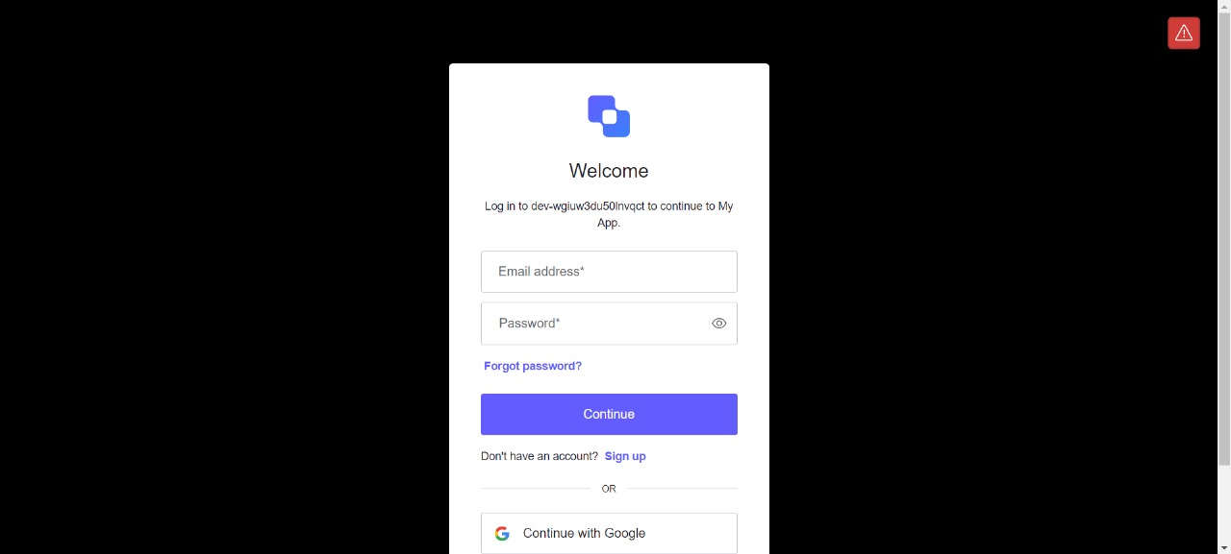

6.1 Authentication

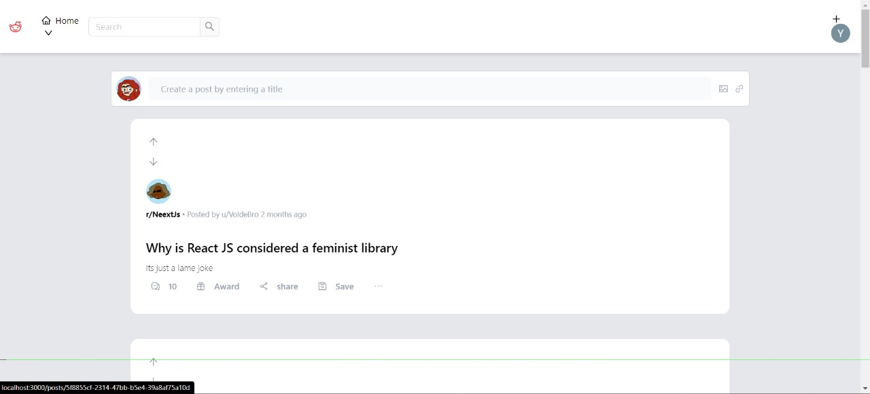

6.2Landing Page

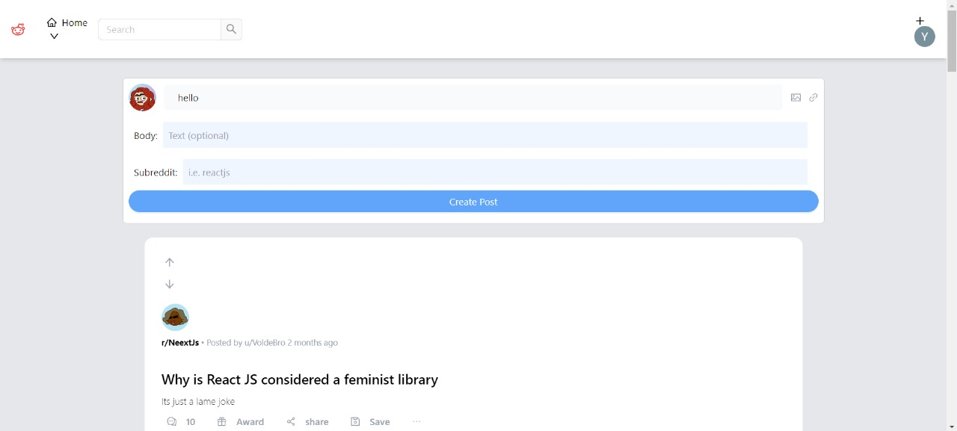

6.3 Create a Post

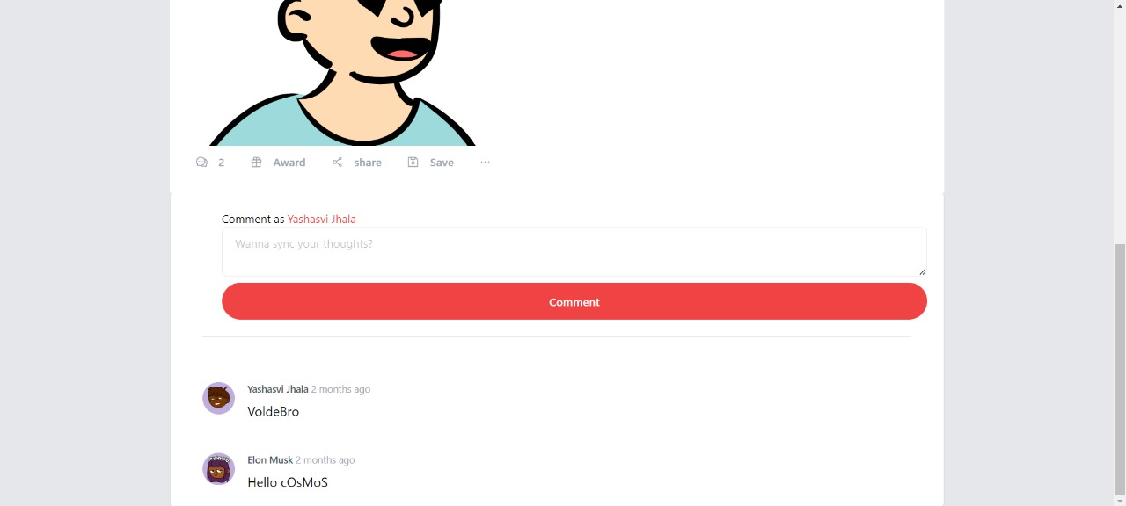

6.4 Posts Page

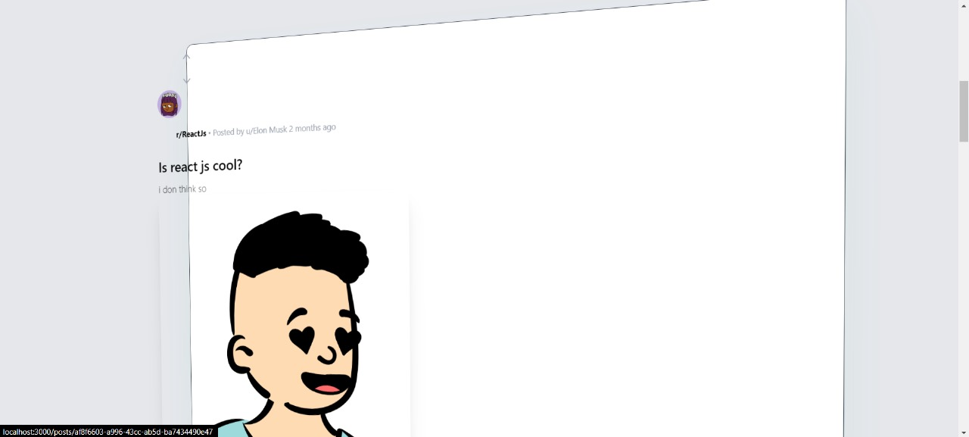

6.5 Enabled Animations

**Chapter 7**

**CONCLUSION**

The development and evaluation of the Reddit clone project have provided valuable insights into the process of building a modern web application using cutting-edge technologies and methodologies. Through the detailed methodology, development process, results, and discussion outlined in this report, several key conclusions can be drawn.

**7.1. Successful Implementation of Modern Technologies**

The Reddit clone project successfully leveraged modern web development technologies such as React.js, Ant Design, GraphQL, Supabase, TypeORM, and TypeGraphQL to create a functional and scalable platform. The integration of these technologies facilitated efficient data exchange, real-time updates, and seamless user interactions, resulting in a robust and user-friendly application.

**7.2. Achievement of Project Objectives**

The project objectives, including the development of essential features such as user authentication, post creation, commenting, and voting, were successfully achieved. The iterative development process, coupled with thorough testing and documentation, ensured that the Reddit clone platform met user requirements and expectations.

**7.3. Positive User Feedback and Satisfaction**

User feedback and satisfaction scores indicated a positive overall experience with the Reddit clone platform. Users appreciated the intuitive user interface, smooth navigation, and responsiveness of the application. Additionally, constructive feedback provided valuable insights for further improvements and enhancements.

**7.4. Identification of Challenges and Constraints**

The project encountered various challenges and constraints, including technical challenges related to integration, optimization, and debugging, as well as resource constraints such as time, budget, and expertise. These challenges were addressed through collaboration, problem-solving, and prioritization of tasks.

**7.5. Opportunities for Future Development**

* Despite the successful implementation of the Reddit clone platform, there are opportunities for further development and optimization. Future enhancements could include additional features such as user profiles, search functionality, moderation tools, and enhanced performance optimizations.
* Overall, the Reddit clone project demonstrates the effectiveness of modern web development technologies and methodologies in creating feature-rich and user-friendly applications. By addressing user needs, leveraging best practices, and embracing innovation, the project sets a solid foundation for future development and expansion. Through continuous iteration, refinement, and collaboration, the Reddit clone platform has the potential to become a leading destination for online discussion and community engagement.

**Appendices :**

<https://github.com/yashasvijhala/wtf>

<https://wtf-9imw.vercel.app/>

**References:**

<https://www.reddit.com/>

<https://en.wikipedia.org/wiki/Reddit>